An instruction on codes implementation

The codes are written in R to conduct computational experiments reported in the paper “A retail store SKU promotions optimization model for category multi-period profit maximization”.

1. The function of files in the codes is described in Table 1.

Table1. the description of files of codes

|  |  |  |
| --- | --- | --- |
| Directory | File | Description |
| ./ | sku-functions.R | some general functions |
| ./Data/ | Data extract from IRI dataset.R | Extract sample data from IRI dataset |
| transform_functions.R | Some data manipulation function used in data extraction |
| SKU data store 234212.Rda  SKU data store 236117.Rda  SKU data store 649405.Rda  SKU data store 657979.Rda | The data sample extracted from IRI, these data are used to conduct further experiments in the paper. |
| /.demand model with promotion indense index/ | SKU forecasting with indexes.R | The implementation of Promotional index model |
| Store 234212 predictions.Rda  Store 236117 predictions.Rda  Store 649405 predictions.Rda  Store 657979 predictions.Rda | Sample forecasting accuracy results from Promotional index model |
| ./ demand model with top-down/ | market share model.R | The implementation of Top-down with market share decomposition |
| attraction-functions.R | Some functions defined for market share model |
| Store 234212 predictions.Rda  Store 236117 predictions.Rda  Store 649405 predictions.Rda  Store 657979 predictions.Rda | Sample forecasting accuracy results from market share model |
| ./ demand models with regularization/ | SKU forecasting model.R | The implementation of high dimensional ADL model estimated by a two-stage sign constrained regularization |
| parameters analysis.R | parameters analysis of the ADL model |
| Store 234212 predictions.Rda  Store 236117 predictions.Rda  Store 649405 predictions.Rda  Store 657979 predictions.Rda | Sample forecasting accuracy results from ADL model |
| Store 234212 parameters.Rda  Store 236117 parameters.Rda  Store 649405 parameters.Rda  Store 657979 parameters.Rda | Parameters estimated by ADL model which are the inputs to the optimization model |
| ./ optimization model/ | opt main.R | The implementation of optimization model by using Genetic algorithm |
| ga-functions.R | Some function defined for the the implementation of optimization model |
| ./ optimization model/results | result-store-234212.Rda  result-store-236117.Rda  result-store-649405.Rda  result-store-657979.Rda | Sample optimization results from optimization model |

1. The implementation of the codes

The sequence of the codes implantation is demonstrated in Figure1. First, extracting sample data from IRI dataset, then estimate the demand model and generate forecasts based on the extracted data, and last generate optimal promotion schedule.

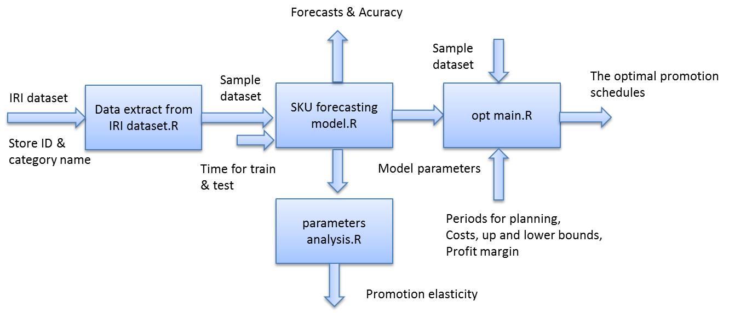

Figure1. Flowchart of the codes implantation

1. **Running of the ‘Data extraction from IRI dataset.R’**

**Input**: the position of the IRI dataset; the store ID and category name which are wanted to be extracted.

**Output**: the sample data including all the required data for the selected store and categories.

The structure of the data sample is organized as a list in R, the data for each store is saved in an individual file. In experiments reported in the paper, we extracted data from four stores, and each store has four categories. Figure 2 demonstrates the structure of the sample data for a store. The first four lists are the data for each product category; the data stored in each list is a matrix. The row of the matrix is IRI week. Assuming the category including *n* SKUs, then in the first *n* columns is the sales of each SKU, and then next n columns are the promotion indictors for each SKU, and then price, display type 1, display type 2, feature type 1, feature type 2, feature type 3, and feature type 4. The list ‘time’ indicate the month in a year, holidays and the week previous the holidays. The list ‘Num’ indicate the number of SKUs in each category.

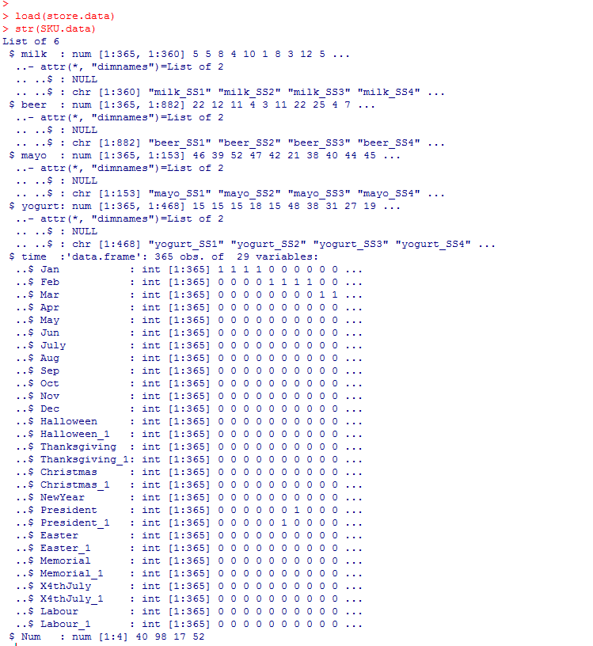

Figure 2 the structure of the sample data for a store

1. **Running of the ‘SKU forecasting model.R’**

**Input**: Store ID, Store Data, time for training, time for testing, length of the rolling periods

**Output**: the estimated parameters for demand model in each rolling periods, the forecasting accuracy overall.

The output of the‘SKU forecasting model.R’ includes two files. One file stores all the coefficients which are the input for the optimization model. One file stores the forecasting accuracy results reported in Table 4 of the paper. The file ‘parameters analysis.R’ is for generating price and display/feature elasticities reported in Fig.2 & Fig.3 in the paper.

1. **Running of the ‘opt main.R’**

**Input**: Store data, coefficients of the demand model, product profit margin, display cost, feature cost, retagging cost, period for promotional planning.

**Output**: the optimal promotional planning: for each SKU in each week, the plan for pricing, display and feature advertising; estimated optimal sales, profits, which are the data source of Table 6 & Table 7, Fig. 4 & Fig. 5 reported in the paper.